RESOLUTION NO.__________

RE: CERTIFICATE OF APPROPRIATENESS UNDER THE
PROVISIONS OF THE ACT OF THE PENNSYLVANIA
LEGISLATURE 1961, JUNE 13, P.L. 282 (53
SECTION 8004) AND BETHLEHEM ORDINANCE NO.
3952 AS AMENDED.

WHEREAS, it is proposed to install a new fence along the rear of the property at 242 E. Wall St.

NOW, THEREFORE, BE IT RESOLVED by the Council of the City of Bethlehem that a Certificate of Appropriateness is hereby granted for the proposal.

Sponsored by: (s)

(s)

ADOPTED BY COUNCIL THIS DAY OF

(s)
President of Council

ATTEST:

(s)
City Clerk

HISTORICAL & ARCHITECTURAL REVIEW BOARD

The applicant is proposing to install a new fence along the rear of the property at 242 E. Wall St.
APPLICATION #3:

Leighton & Erica Brew
242 E. Wall St.
Bethlehem, PA 18018

OWNER:

__________________________________________________________________________

The Board upon motion by Gen Marcon and seconded by Diana Hodgson adopted the proposal that City Council issue a Certificate of Appropriateness for the following:

- New fence 4’ high section installed with flat top.

2. Installing a curved (concave) top gate.

3. Fence to be left natural.

4. The motion was unanimously approved.

__________________________________________________________________________

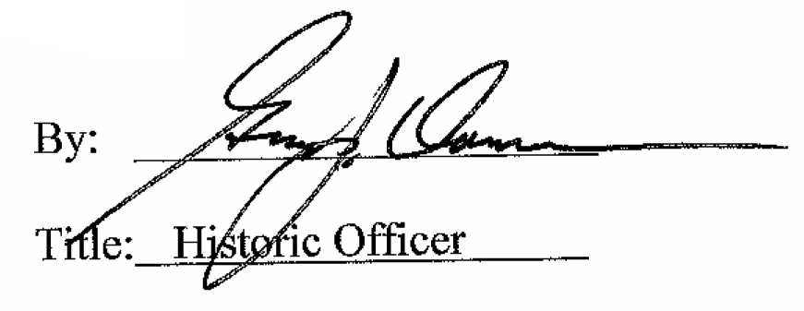

Date of Meeting: May 3, 2017

